Christian Assembly Newsletter April 2019
Breaking of Bread Service

We need to prepare our hearts as we meet on the Lord’s Day to break bread. We remember with gratitude what Christ has done for us. As we remember the Lord and what He endured for us, may worship flow readily from our hearts and lips. “Let us offer the sacrifice of praise to God continually, that is, the fruit of our lips giving thanks to His Name. Hebrew 13:15. How often? As Paul told the believers in Troas: “On the first day of the week we are gathered together to break bread…” Acts 20:7. Once a week.
We thank the Lord for the privilege of coming together to remember the Lord. Many don’t have this privilege. We remember our risen Lord- crucified, risen, ascended and exalted o the throne on high, until He comes. Our prayers and songs should be centred on these themes. When the deacons prepare the elements into the cups and plates, the congregation should be in silent meditation.
The Words of Jesus:
The Lord Jesus on the night when He was betrayed, took bread, gave thanks and said: “This is My body which is for you: Do this in remembrance of Me.” 1 Cor. 11:24. “In the same way also the cup, after supper, saying: “This cup is the new covenant in My blood. Do this, as often as you drink it, in remembrance of Me.” v25. For as often as you eat this bread and drink the cup, you proclaim the Lord’s death until He comes. Jesus used the Passover meal to reveal His redemptive purpose in coming to earth: He has come to heal and redeem broken humanity. He left Heaven’s glory, His home, to come to sin-cursed earth as a ransom for our iniquity. As we partake the emblems of His suffering we acknowledge His Lordship.
Examine Ourselves:
We must partake of the Lord’s Supper in a worthy manner and not regard iniquity in our hearts, therefore whoever eats the bread and drinks the cup in an unworthy manner will be guilty of profaning the body and blood of the Lord. So we are called to examine ourselves, v26. We need to confess our sins: for “God is faithful and just to forgive us our sins and cleanse us from all unrighteousness.” 1 Jn 1:9. We must partake of the Lord’s Supper in a worthy manner with cleansed hearts, otherwise we will be guilty of profaning the body and blood of the Lord and bring judgment upon ourselves. 1 Cor. 11:27-29.
The Supreme Sacrifice:
We remember the Lord Jesus who redeems us from the curse of the law and from all iniquity- what He went through as an atoning sacrifice for our sins in accordance with the Scriptures. We remember this great work everyday but especially on the Lord’s day during the Breaking of Bread service. We want to remember Him and all He went through because He loved us. “For Christ also suffered for our sins once for all, the righteous for the unrighteous, to bring us to God, being put to death in the flesh but made alive in the Spirit.” 1 Peter 3:18.
“The love that Jesus had for me
To suffer on that cruel tree
Is more than tongue can tell.”
He who was sinless paid the supreme sacrifice for our sins. Today we remember Him who said: “I was dead but now I live: and behold now I am alive forever more.” Rev. 1:8. “Of His own will He brought us forth by the Word of truth that we should be a kind of first fruits of His creatures.” James 1:18. By grace He tasted death for us. May we bow in adoration and worship and be thankful for who He is and for what He has done. What a wonderful Saviour is Jesus my Lord!
Jesus surrendered His body and blood to bring us into a relationship with Him: and to make us whole and well.
Conclusion:
Lifted up was He to die,
“It is finished” was His cry;
Now in heaven, exalted high,
Hallelujah! What a Saviour.

Our risen and reigning Lord God Almighty.
Glorious Saviour, Glorious Lord!

-Contributed by: Sis. Jeanette Chia

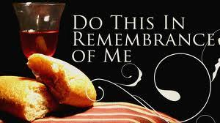

Beholding Him in increasing measure

Exodus 33:11a (NASB)
Thus the Lord used to speak to Moses face to face, just as a man speaks to his friend… I just started work in Houston, and this past week I had the opportunity to dine with a people who normally work remotely in other cities. Though I had interacted with them before, there was something added to our relationship that phone or email could not replicate. I felt like I finally was starting to know these colleagues.
Every meeting and meal was substantially different, because they were very different people. Some were more willing to share their lives, while others were more reserved. However, for all of them, one thing was true. As I saw their faces more and more each day (even just over 1 week), there was an increasing two-way openness between us. Exodus 33:23 (NASB)
“Then I will take My hand away and you shall see My back, but My face shall not be seen.”
God answered Moses’ prayer as far as possible. He allowed all of His goodness to pass before Moses (v19), and covered Moses with His hand (v22) to allow Moses to see His back in full glory. Through it all, Moses became the man closest to God in his generation.
Dear brothers and sisters, it is amazing that God desires to reveal His glory to us, and it’s even more amazing that He has provided ALL in His Son Jesus Christ! Let us take hold of this blessing of knowing Him in increasing measure, and even of beholding Him face-to-face.
For now we see in a mirror dimly, but then face to face. -1 Corinthians 13:12a (NASB)
-Contributed by Bro. Lemuel Soh


Notes and News

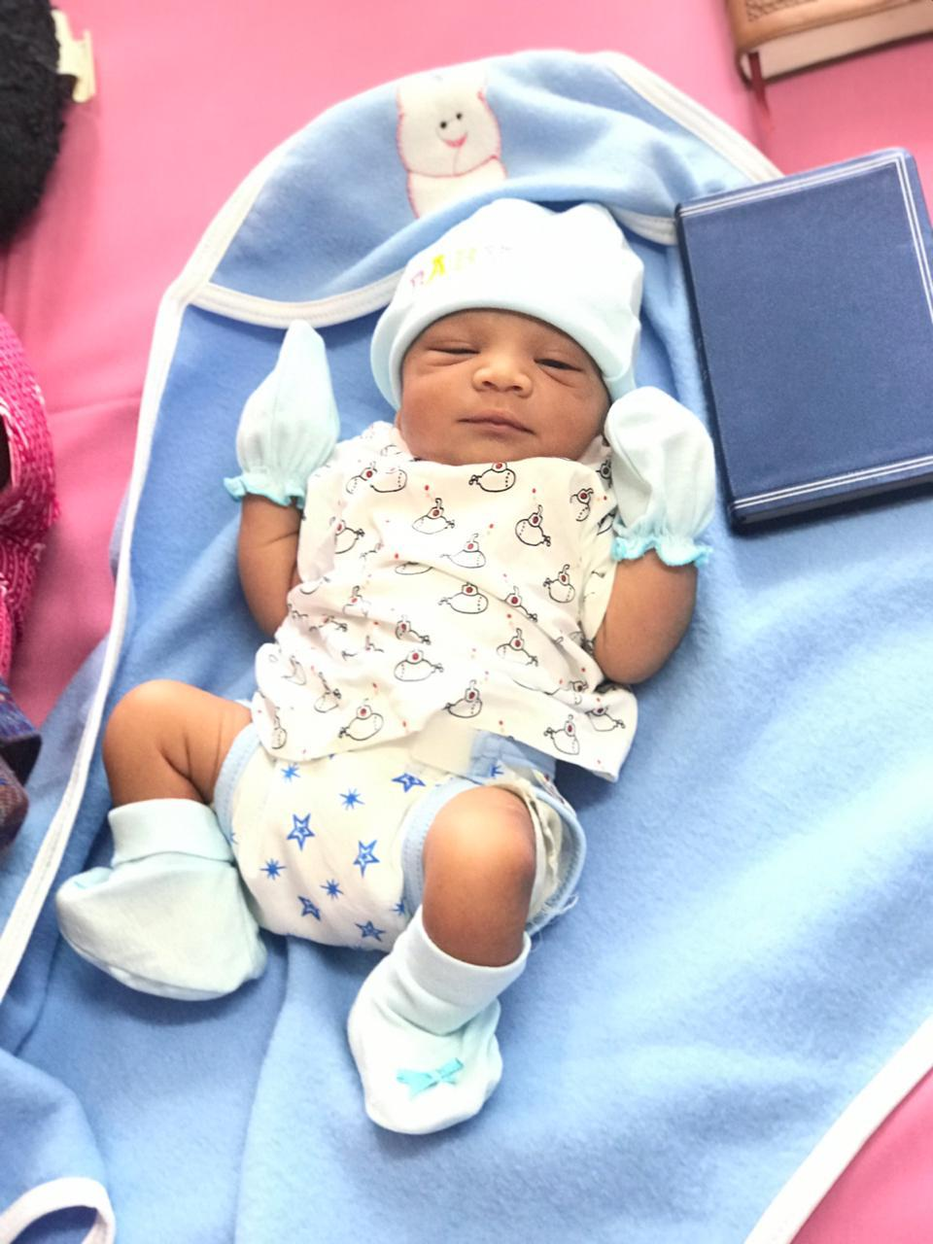
Bundle of joy
We thank and praise God for the birth of Joshua Daniel Rai, son of Bro. Anil and Sis. Rachel! Refer to their sharing below.

“Dear All,
We thank you for the persistent prayers offered for a healthy, safe confinement.
We are blessed with baby boy on the 5th March, 2019.
By the grace of God, he was dedicated in the house of God on the 6th day and was named Joshua Daniel Rai by the God servant at Hebron Church, Bangalore, India.
Yours in His eternal bonds,
Anil & Rachel”

Cambodia Mission Trip
We thank God for the safe journey of all the Cambodia Missioners (total 7 brothers & sisters) and God’s provision of the clothes they brought over. Many children as well as adults have indicated their interest to accept the Lord as Savior - Do continue to pray for the Holy Spirit’s on-going work in their lives as well as the growth of seeds that have been sown. The economy in Cambodia is also very bad so please pray for God’s provision & protection for His children.


Be careful for nothing; but in everything by prayer and supplication with thanksgiving let your requests be made known unto God. (Philippians 4:6)
And the peace of God, which passeth all understanding, shall keep your hearts and minds through Christ Jesus. (Philippians 4:7)

Prayer items
Watch and Pray

Pulpit ministry
May we all come before the Lord with a heart of reverence. Do remember our speakers and translators in prayer.
Our speakers are as follows:
Date | Speakers
Date | Wilkie | Asiawide | Gospel
07 Apr 2019 | Ling In Kee | Stephen Li | Billy Yeo
14 Apr 2019 | Yeo Choon Guan | Teo Ching Han
21 Apr 2019 | Chua Meng Khiang | Chng Yak Beng
28 Apr 2019 | Tan Boon Guan | Chua Meng Khiang

Baptism Service - 21July 2019
Pray for the upcoming baptism service that God will convict those who have yet to take the step of obedience to be willing to undergo the waters of baptism.

Gospel Meeting
Gospel meeting held monthly on the 1st Sunday at 5pm in Wilkie - it is a spiritual warfare so do keep in prayer all who are involved:
- Speakers & translators
- Pianists
- Those who give out gospel tracts
- Members who invite family & friends
- Involvement of young and old to support this work of the “great commission”

Youth Camp 19-20th April 2019
Pray that the youths will gain new insights of God and develop a deeper relationship with Him during the 2 days.

Those working with the youth

Pray for wisdom and discernment for those working with/guiding the youths in their walk with the Lord and how to unite the assembly as one body in Christ in activities, ministries and worship.

Elders and deacons
May the meetings be Christ-centered and discussions be on matters that God is concerned with.

Church Camp – 10 to 14 June 2019 (Batam)
Theme: “A man after God’s heart” (Acts 13:22)
Closing date of application: 14 April 2019
Items to submit: Completed form, transport fees and passport copy.

We have church camps year in year out, let us not take such camps for granted. Pray for hearts to hunger & wait in anticipation of God’s Word for the coming church camp.

Remember brothers and sisters who are not well, elderly and those who are not able to attend church:

- Bro Bobby Sng who has a weak heart
- Mr Leong & his wife Irene
- Bro Sng Hock Heng
- Bro Loh
- Sis Wong Hee Aik who is still in a coma. May the Lord’s will & purpose be done.
- Sis Sharon Chang
- Sis Wang Wei
- Bro. Liu Yi Quan who has swollen leg and intermittent fever. He has returned to China for treatment.
- Sis Lee Seok Hua
- Sis Goh Leng Kum
- Sis Teo Siew Eng
- Sis Christina Tan
- Others whom the Lord knows by name

May they experience God’s Presence during this time of pain & take comfort in His love & grace.

Church ministries
Your prayer support and involvement in any of the ministries would be an encouragement to the body of Christ.
From him the whole body, joined and held together by every supporting ligament, grows and builds itself up in love, as each part does its work.
-Ephesians 4:16


Newsletter … sharing of testimonies, pictures and articles to edify brothers and sisters

Transportation needs … Pray for brothers and sisters to volunteer to serve as Gospel van drivers and for those with cars to give lifts to those in needs especially the elderly and the younger ones living in various areas.
Note:
Please note that prayer requests are reported up to the 3rd Wednesday of every month in order to prepare for translation and preparation for the printing of the newsletter, which will target to be available on the 1st Sunday of every month.
Those prayer items requested on the 4th Wednesday of every month, which is valid only for the following month, will not be reported because by the time the next newsletter is printed, these prayer requests would have been outdated. We thank all church members for their understanding.

